C#

Object Oriented programming

Objective
The primary objective for this lab is as follows:
- To create and use references.
- To consolidate on passing by value and passing by reference

Part 1 – Creating and using reference types

Step by step
- In the labs project, create a class called Account with the following fields
private int id;
private string owner;
private double balance;
and methods:
void Deposit(double amount) { }
void Withdraw(double amount) { }

- Create a constructor for the Account class to set its fields
(id, owner and balance).
- Modify the Deposit and the Withdraw methods to make sure no one can Deposit a negative amount of money or Withdraw the money they don't have (less than their balance).
- Create a method called GetDetails() to return details of the account as a string made up of the id + owner + balance (put a ‘,’ between these)
- In the Program class, create a static method called Lab2() and then call this method from within Main()
- Comment out the call to any other method call.
- In the Lab2() method create an instance of the Account class
And then invoke its Deposit() and Withdraw() methods.
- Call the Account instance's GetDetails() method and then print the result to make sure your code works.

Part 2: Create a graphical application

Objective
You will further your understanding of object oriented programming.
In this lab you'll create a graphical application instead of a Console app.

Part 1
You'll soon be creating a graphical application which is new. You'll copy and paste many lines of code. You are not required to understand how the graphics code works but it is not too complex to investigate by yourself.
- Add a new Windows Form application called GamesApp to your Labs solution.
Right mouse click on the Labs Solution and then select the
Add > New project… menus
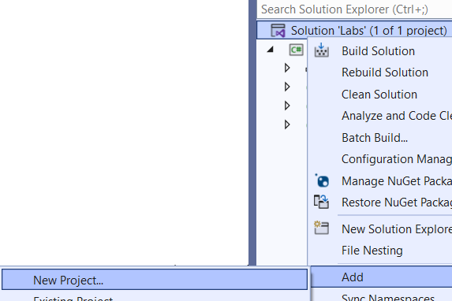
- Create a new Windows Forms App called GameApp by searching for “Windows” and by selecting the Windows Forms App (.Net Framework) option
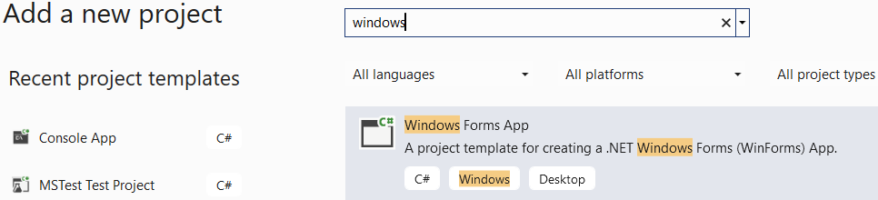

- Right mouse click on the newly created GameApp project and then select the “Select as Startup Project…” menu
- Have a look at the Program class. It creates an instance of a class called Form1 which represents a Windows Form. You'll use this class to display your graphical objects.
- You need a canvas upon which you can draw and show your animation. In this case you'll create a number of ball objects bouncing inside a rectangle (the world).
You can get creative later and do something else but for now, please follow the steps. The aim is to investigate OO concepts and not concentrate on animation and graphics.
- Click on the body of the Form and then press F4 to see its properties (if not displayed already)
- Click the lightening symbol to see the form's events.
An event is an action which you can handle in code. For example, when a user clicks on a control, the control's click event is fired. In this application, we're after the Paint event which is fired when the form needs to be redrawn or repainted.
- Double-click on the Paint event from the list of events. You'll then be redirected to the code behind the form.
- Type the following code in the Paint event. This code clears the screen and draws a red reactangle. 10,10,600 and 400 is the world's dimensions.
private void Form1_Paint(object sender, PaintEventArgs e)
{
e.Graphics.Clear(Color.Gray);
e.Graphics.FillRectangle(Brushes.Red, 10, 10, 600, 400);
}

- Run the application to make sure everything works so far.
- Stop running by closing the Form.
- Double-Click on the Form1 icon in the Solution Explorer window to view it in design mode.
- Press F4 and then click to see the form's events.
- Double click on the Load event from the list to view an event which fires when the form is loaded for the first time.
Type the following code in the Load event in order to create a timer which fires every 50 millisecond.
private void Form1_Load(object sender, EventArgs e)
{
Timer t = new Timer();
t.Interval = 50;
}
You will need to press Ctrl-. (Control dot) On the word Timer and then select using Timer = System.Windows.Forms.Timer;

- Add the following text to the above method t.Tick +=
and then press the Tab key to create an event handler for the Timer's tick event.
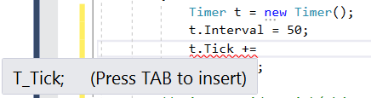
- In the Tick event type: this.Invalidate();
This will force the Paint event to fire every 50ms.
- Back in the Form Load event, activate the timer by adding this line of code: t.Start();
From now all your code for drawing will go into the Paint event.
Your code will look like:
private void Form1_Load(object sender, EventArgs e)
{
Timer t = new Timer();
t.Interval = 50;
t.Tick += T_Tick;
t.Start();
}

Create a class called Ball
- Create a class called Ball with the following fields
public int x, y, w, h;
private int dirX, dirY;
X axis
Y axis axis
x,y axis
w
h

x and y represent the top coordinate of the shape (ball) within an upside down coordinate system. dirX and dirY are the amount by which a ball Moves in the x and y directions.
Note: We must create these as property procedures but elected to make these public vars for simplicity.
- Create a constructor to set every field (x,y,w,h,dirX, dirY).
- To practice constructor chaining, create another constructor to set all the fields except dirX and dirY.
Using constructor chaining, call the first constructor and pass it dirX=1 and dirY=1.
- Create a method called Move() in the Ball class.
In this method, increase x by dirX and y by dirY and then follow a series of tests to make sure the ball Moves within a designated world area (x=10, y=20, width=600, height=400) which you set in step 8.
if (x < 10) then set x=10 and change the sign of dirX
Tip: dirX = -dirX.
Do the same for the y coordinate(changing dirY of course).
if (x > 600 – the width of the ball) then set
x=600 – the width of the ball and reverse the sign of dirX.
- Do the same for the y coordinate taking the ball's height into account and the overall height of 400 for the world in which a ball can travel in.
- Create an array field (at the beginning of the class Form1) as: Ball[] balls;
public partial class Form1 : Form
{
Ball[] balls = new Ball[3];

- Back in the Form Load event handler, create three instances of Ball and place them inside the balls field (see below).
private void Form1_Load(object sender, EventArgs e)
{
balls = new Ball[]
{
new Ball(30, 30, 20, 20, 2, 3),
new Ball(40, 40, 30, 30, 3, 4),
new Ball(80, 90, 20, 40, 4, 3)
};

Timer t = new Timer();
t.Interval = 50;
t.Tick += T_Tick;
t.Start();
}
- In the Paint event, create a foreach loop to go through each ball and run its Move() method. You will then draw the ball after moving it. Please use the code below to draw a ball:
e.Graphics.DrawEllipse(Pens.Yellow, b.x, b.y, b.w, b.h);
// where b is the ball reference you created earlie r
- If everything works, you should see all 3 objects moving around within the world's rectangle.
If you have a need for speed, then increase the values of dirX and dirY of each ball.

Part 2 - Using a struct (Optional)
System.Drawing.Rectangle is a struct which is defined by Microsoft and can be useful to us in this lab
This struct can combine 4 attributes in one. These are X,Y,Width and Height
It has other Properties such as Right, Bottom, Left (or X) and Top (or Y)
Here is a sample code to guide you.
public class Ball
{
Rectangle world = new Rectangle(10, 10, 600, 400);
public Rectangle Rec { get; set; }
// …
public Ball(Rectangle rectangle, int dirX, int dirY)
{
Rec = rectangle;
…
…
}

// In the Ball’s Move method:

Rec.Offset(dirX, dirY);

if(Rec.Right > world.Right)
{
dirX = -dirX;
Rec.Offset(dirX, 0);
}
}

To create a new Ball do:
Ball b = new Ball( new Rectangle(100,50,30,30), 2, 3);

** End **

